**Amar Gajanan Mohite**

Section – IFT562

**Arizona State University**

Instructor**:** Daniel Wells

**Activity 11 – Troubleshoot CloudFormation**

Date – 02/25/2024

At the end of the "Practicing Querying JSON" in Task 1, enter your full name in the command prompt, and take a screenshot.

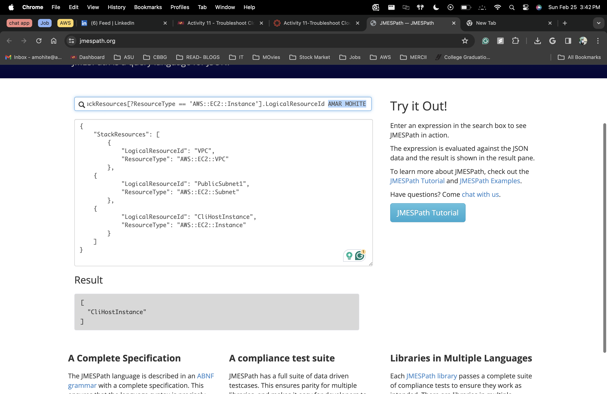

At the end of Task 2.5, run the aws cloudformation describe-stacks command, enter your full name in the command prompt, and take a screenshot.

3.238.183.125

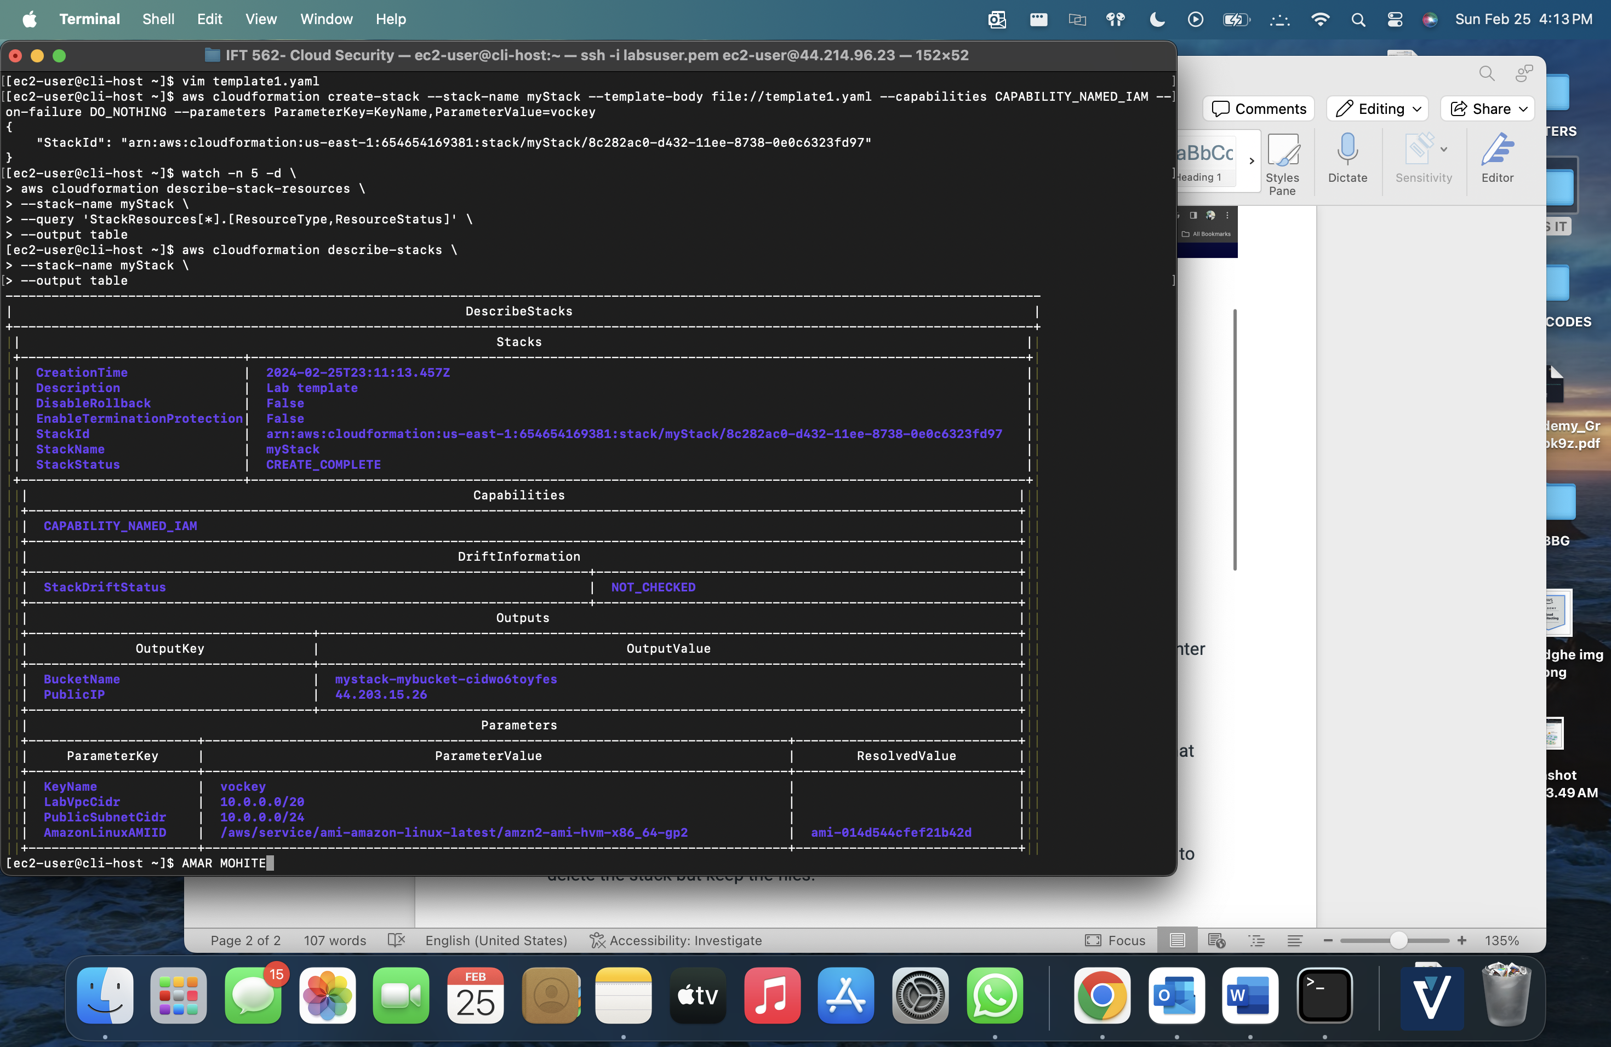

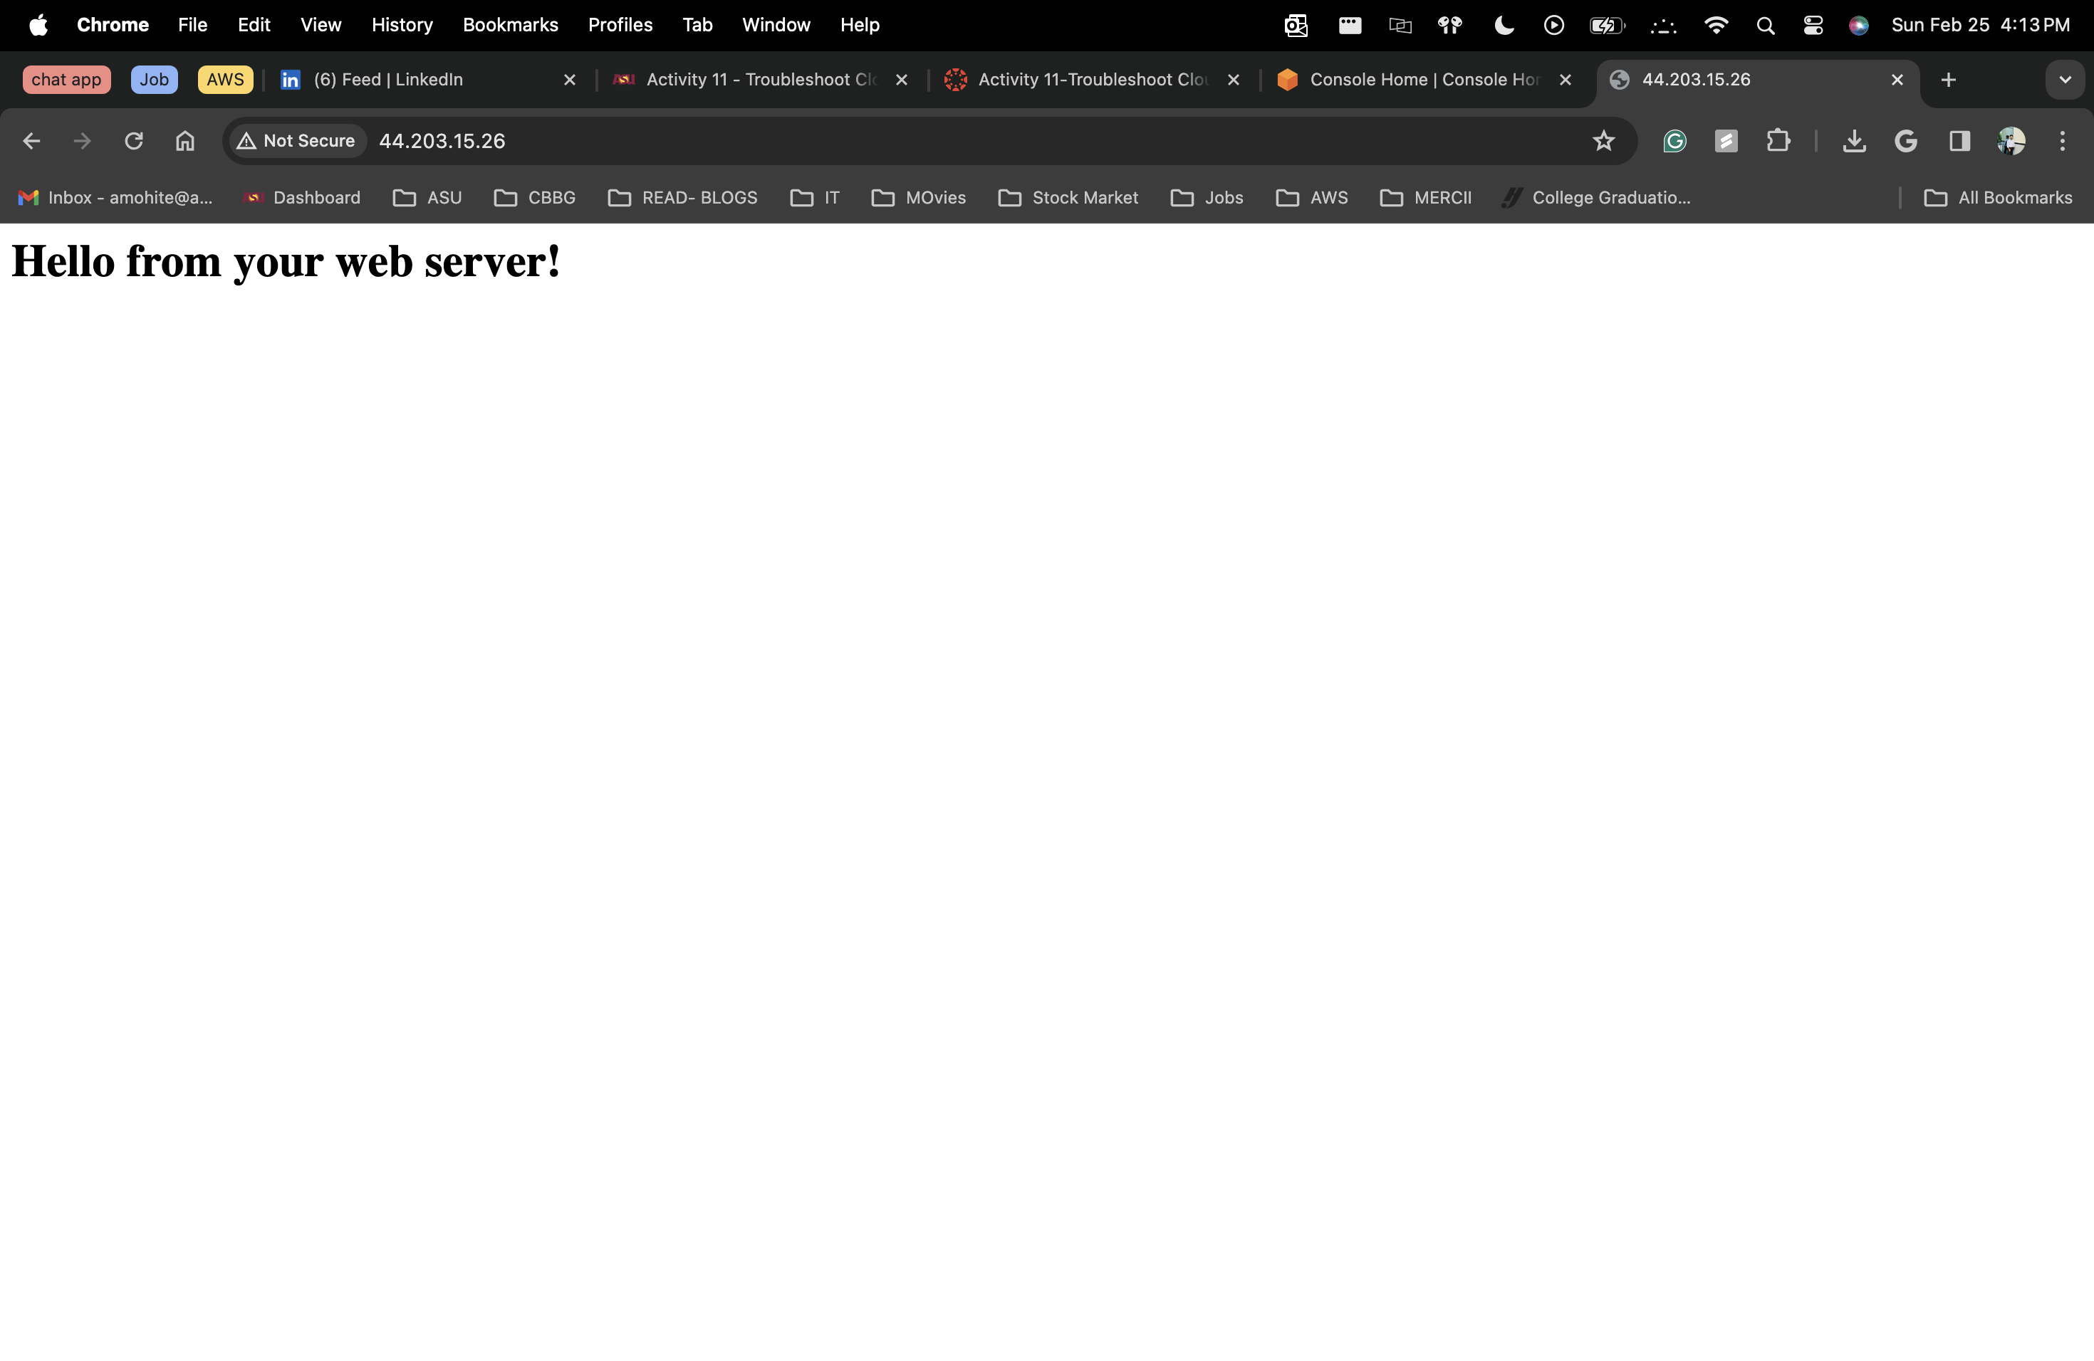

At the end of Task 3, try to update the stack and take a screenshot of the error that is shown.

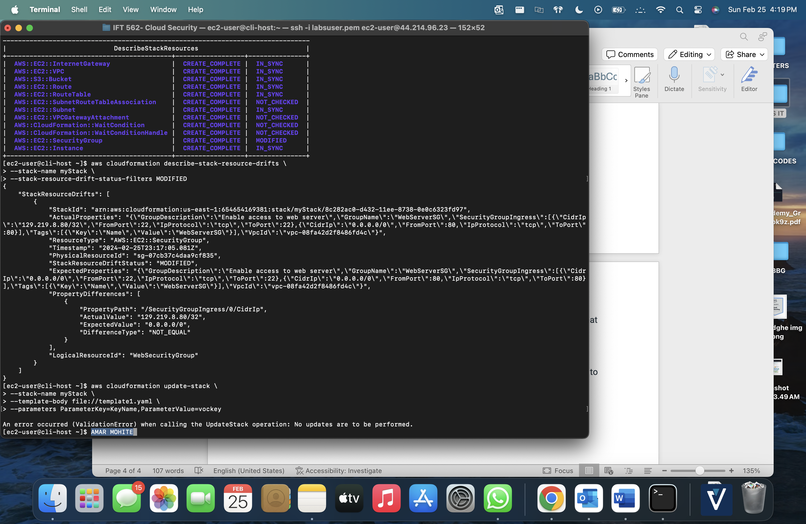

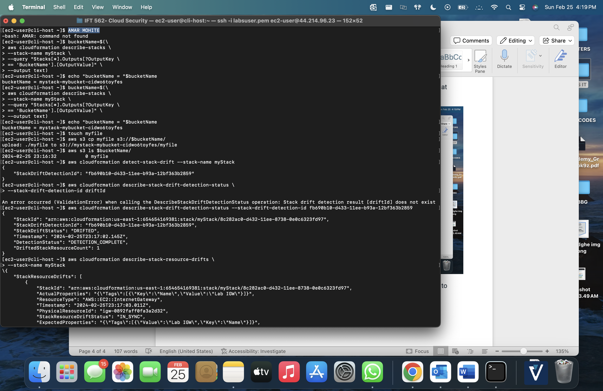

In the Challenge section, take a screenshot of the AWS CLI command necessary to delete the stack but keep the files.

